AMAZON S3 – WEBSITE
- S3 can host static websites that can be accessible on the internet
- The website URL will be depending on the region
- http://bucket-name.s3-website-aws-region.amazonaws.com OR
- http://bucket-name.s3-website.aws-region.amazonaws.com
- If you get a 403 forbidden error, make sure the bucket policy allows public reads!
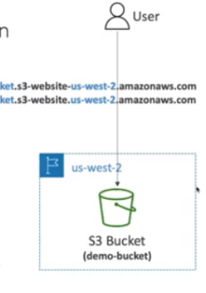
Enabling Static Website of S3:
- Create a bucket and upload some files.
- Go to the Navigate tab and look for Static Website hosting. Edit and enable the same. Give the relevant information regarding the same.
- It will give you the static website hosting URL.

